TASK 2
#include <iostream>
#include <string>
using namespace std;

class Node {
public:
string title;
Node *next;

Node(string t) : title(t), next(nullptr) {}
};

class Playlist {
private:
Node *head, *tail;
public:
Playlist() : head(nullptr), tail(nullptr) {}

void addSong(string title) {
Node *newNode = new Node(title);
if (!head) {
head = tail = newNode;
} else {
tail->next = newNode;
tail = newNode;
}
cout << "Added: " << title << endl;
}

void deleteFront() {
Node *temp = head;
cout << "Deleted: " << temp->title << endl;
head = head->next;
delete temp;
}

void searchByTitle(string title) {
Node *temp = head;
while (temp) {
if (temp->title == title) {
cout << "Found \"" << title << endl;
return;
}
temp = temp->next;
}
cout << "Song \"" << title << "\" not found.\n";
}

void searchByPosition(int position) {
Node *temp = head;
int pos = 1;
while (temp && pos < position) {
temp = temp->next;
pos++;
}
if (temp && pos == position) {
cout << "Song at position " << position << ": " << temp->title << endl;
} else {
cout << "No song at position " << position << endl;
}
}

void display() {
Node *temp = head;
int pos = 1;
cout << "Playlist:\n";
while (temp) {
cout << pos << ". " << temp->title << endl;
temp = temp->next;
pos++;
}
if (head == nullptr) cout << "(empty)\n";
}

~Playlist() {
while (head) {
Node *temp = head;
head = head->next;
delete temp;
}
}
};

int main() {
Playlist playlist;
playlist.addSong("Song A");
playlist.addSong("Song B");
playlist.addSong("Song C");
playlist.display();

playlist.searchByTitle("Song B");
playlist.searchByPosition(2);

playlist.deleteFront();
playlist.display();

return 0;
}

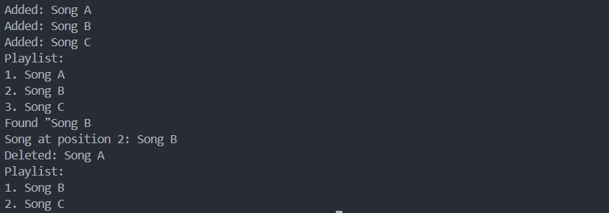

TASK 3
#include <iostream>
#include <string>
using namespace std;

class Node {
public:
string data;
Node *next;

Node(string t) : data(t), next(nullptr) {}
};

class CustomerQueueSystem {
private:
Node *head, *tail;
public:
CustomerQueueSystem() : head(nullptr), tail(nullptr) {}

void addCustomer(string name) {
Node *newNode = new Node(name);
if (!head) {
head = tail = newNode;
} else {
tail->next = newNode;
tail = newNode;
}
cout << "Added: " << name << endl;
}

void deleteFront() {
Node *temp = head;
cout << "Deleted: " << temp->data << endl;
head = head->next;
delete temp;
}

void deleteEnd() {
if (!head) return;
if (head == tail) {
cout << "Deleted: " << head->data << endl;
delete head;
head = tail = nullptr;
return;
}
Node *temp = head;
while (temp->next != tail) {
temp = temp->next;
}
cout << "Deleted: " << tail->data << endl;
delete tail;
tail = temp;
tail->next = nullptr;
}

void DeleteAtPos(int pos) {
if (pos <= 0 || !head) {
cout << "Not possible" << endl;
return;
}
if (pos == 1) {
deleteFront();
return;
}
Node *prev = head;
for (int i = 2; prev->next && i < pos; i++)
prev = prev->next;
Node *cur = prev->next;
if (!cur) {
cout << "Position out of bounds.\n";
return;
}
prev->next = cur->next;
if (cur == tail) tail = prev;
cout << "Deleted: " << cur->data << endl;
delete cur;
}

void display() {
Node *temp = head;
int pos = 1;
cout << "CustomerQueueSystem:\n";
while (temp) {
cout << pos << ". " << temp->data << endl;
temp = temp->next;
pos++;
}
if (head == nullptr) cout << "(empty)\n";
}

~CustomerQueueSystem() {
while (head) {
Node *temp = head;
head = head->next;
delete temp;
}
}
};

int main() {
CustomerQueueSystem TicketCounter;
TicketCounter.addCustomer("Alice");
TicketCounter.addCustomer("Bob");
TicketCounter.addCustomer("Charlie");
TicketCounter.display();

TicketCounter.deleteFront();
TicketCounter.display();

TicketCounter.deleteEnd();
TicketCounter.display();

TicketCounter.DeleteAtPos(1);
TicketCounter.display();

TicketCounter.DeleteAtPos(1); // Attempt to delete from empty list
TicketCounter.display();

return 0;
}
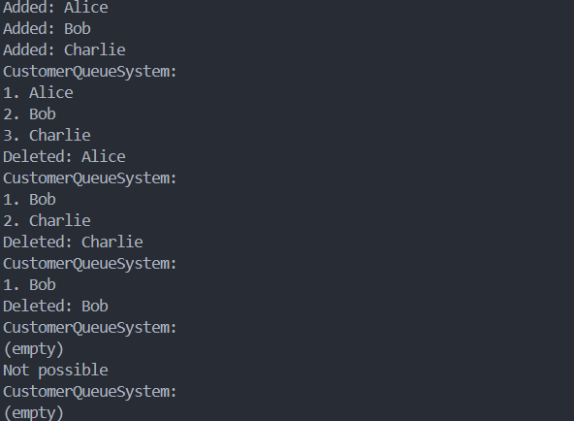
1000 litre truck dilemma
We have four nodes each with a demand value and a distance value we need to find the order of fuelling which node/location comes first.
Since we know, we cannot move backwards but we can move as much as we want. For four nodes (A, B, C, D).
We will start by ratios such that Demand/Distance, as we need high demand and less distance. Hence ratio being the most optimal path (for now).
We can either create four variables for nodes or an array of four elements.
Which would make it easier to compare those ratios, the higher the ratio the higher the priority.
Along with that we will also use a status (flag) so when the truck transverses again it would read the value but ignore it as defined by the status.

